Experiment 2: Client–Server Communication Between Two Virtual Machines

Configure two virtual machine instances in VirtualBox to establish client–server communication and implement a basic TCP-based chat application between the two virtual machines.

Objective
- Create/prepare two Ubuntu Virtual Machines in VirtualBox.
- Configure both VMs on the same virtual network.
- Assign/check the IP address of both VMs.
- Test connectivity using the ping command.
- Designate one VM as the Server.
- Designate the other VM as the Client.
- Create a TCP server program on the Server VM.
- Create a TCP client program on the Client VM.
- Establish a connection between the two VMs.
- Send and receive messages through the chat application.
- Demonstrate the working chat application.
- Capture screenshots of configuration, connectivity and chat communication.

- Checking Network Configuration and IP Address
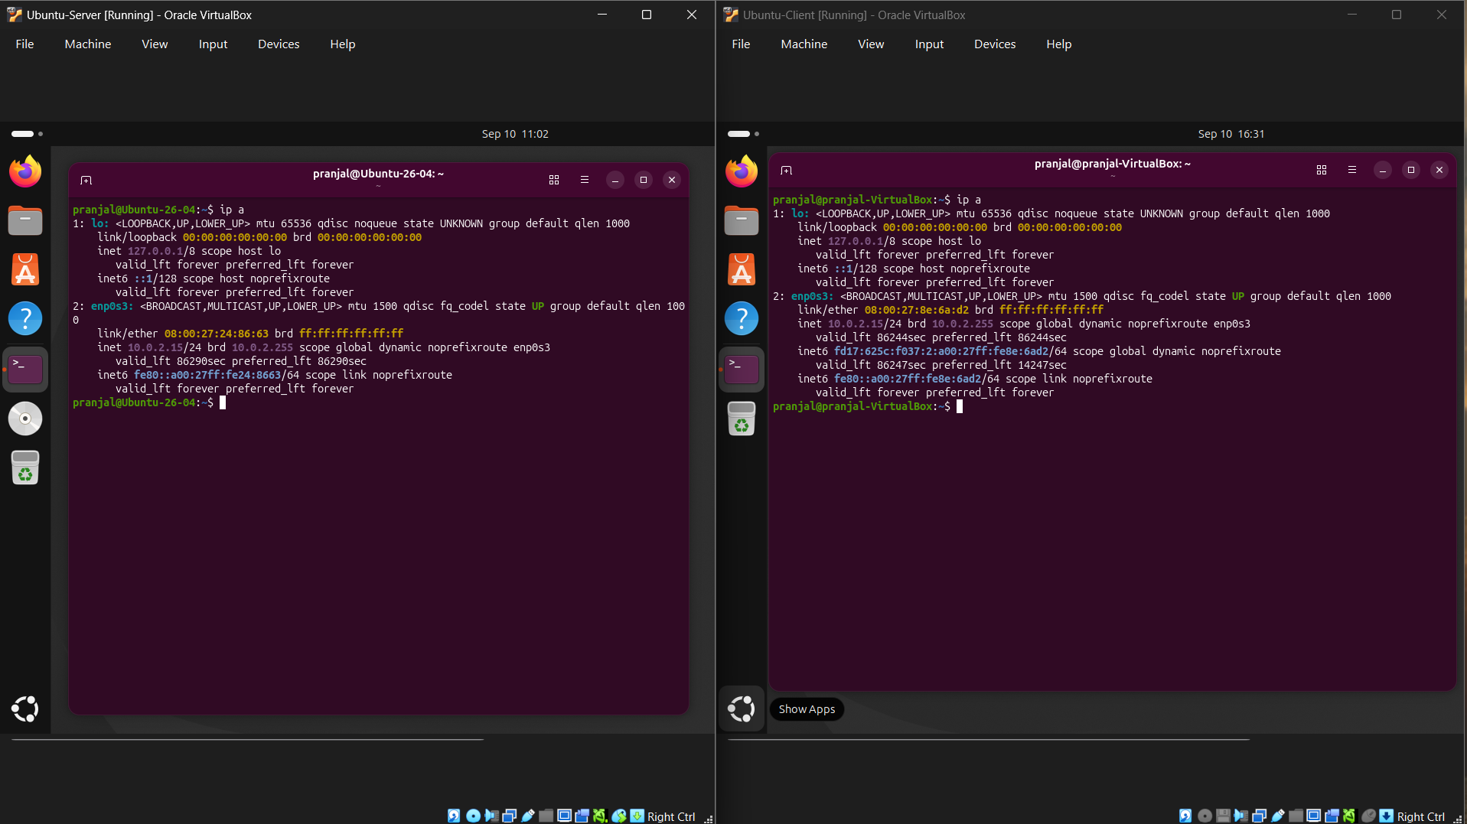

- Creating a Customized NAT Network in VirtualBox
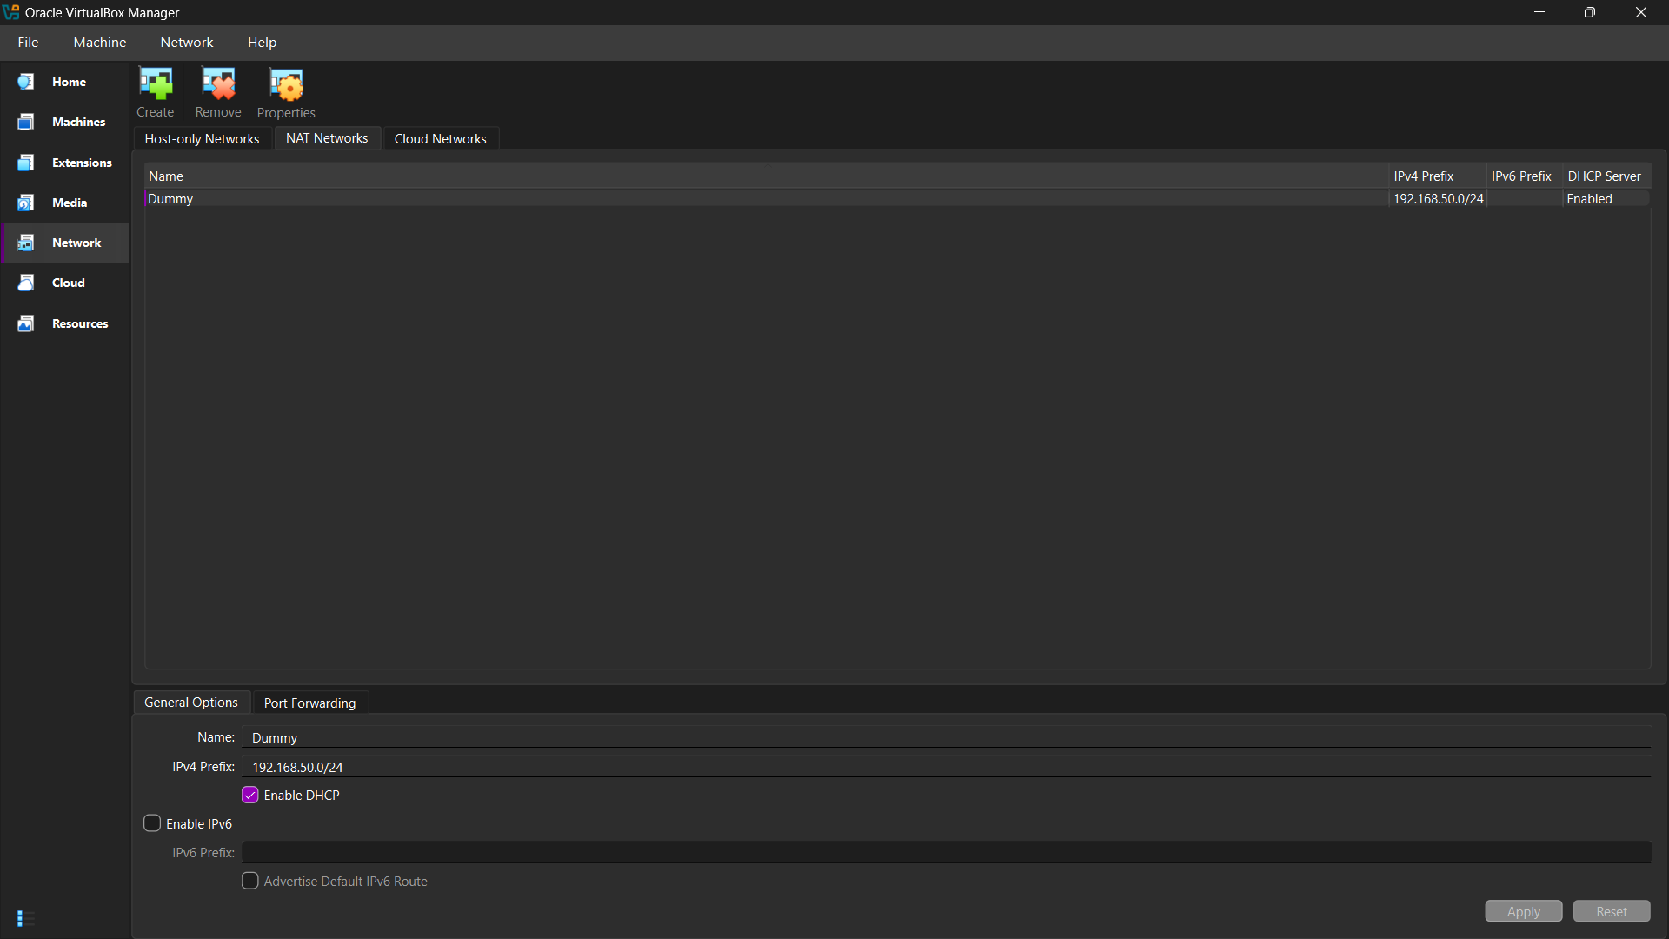

- Configuring the VM with NAT Network
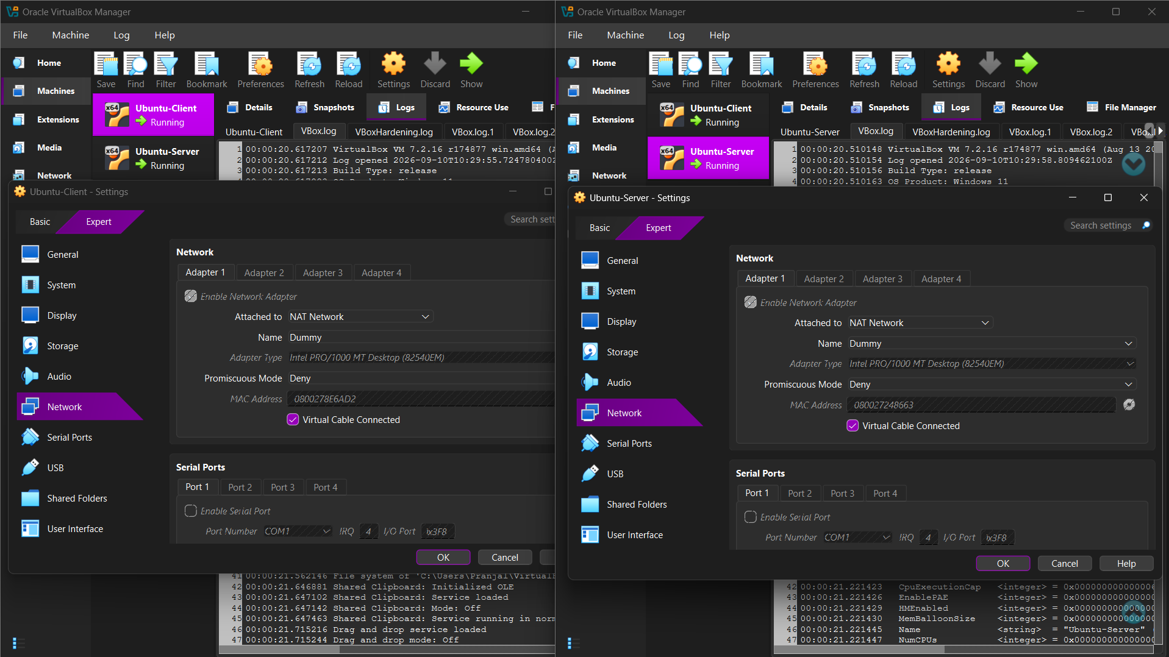

- Verifying IP Addresses After Network Configuration
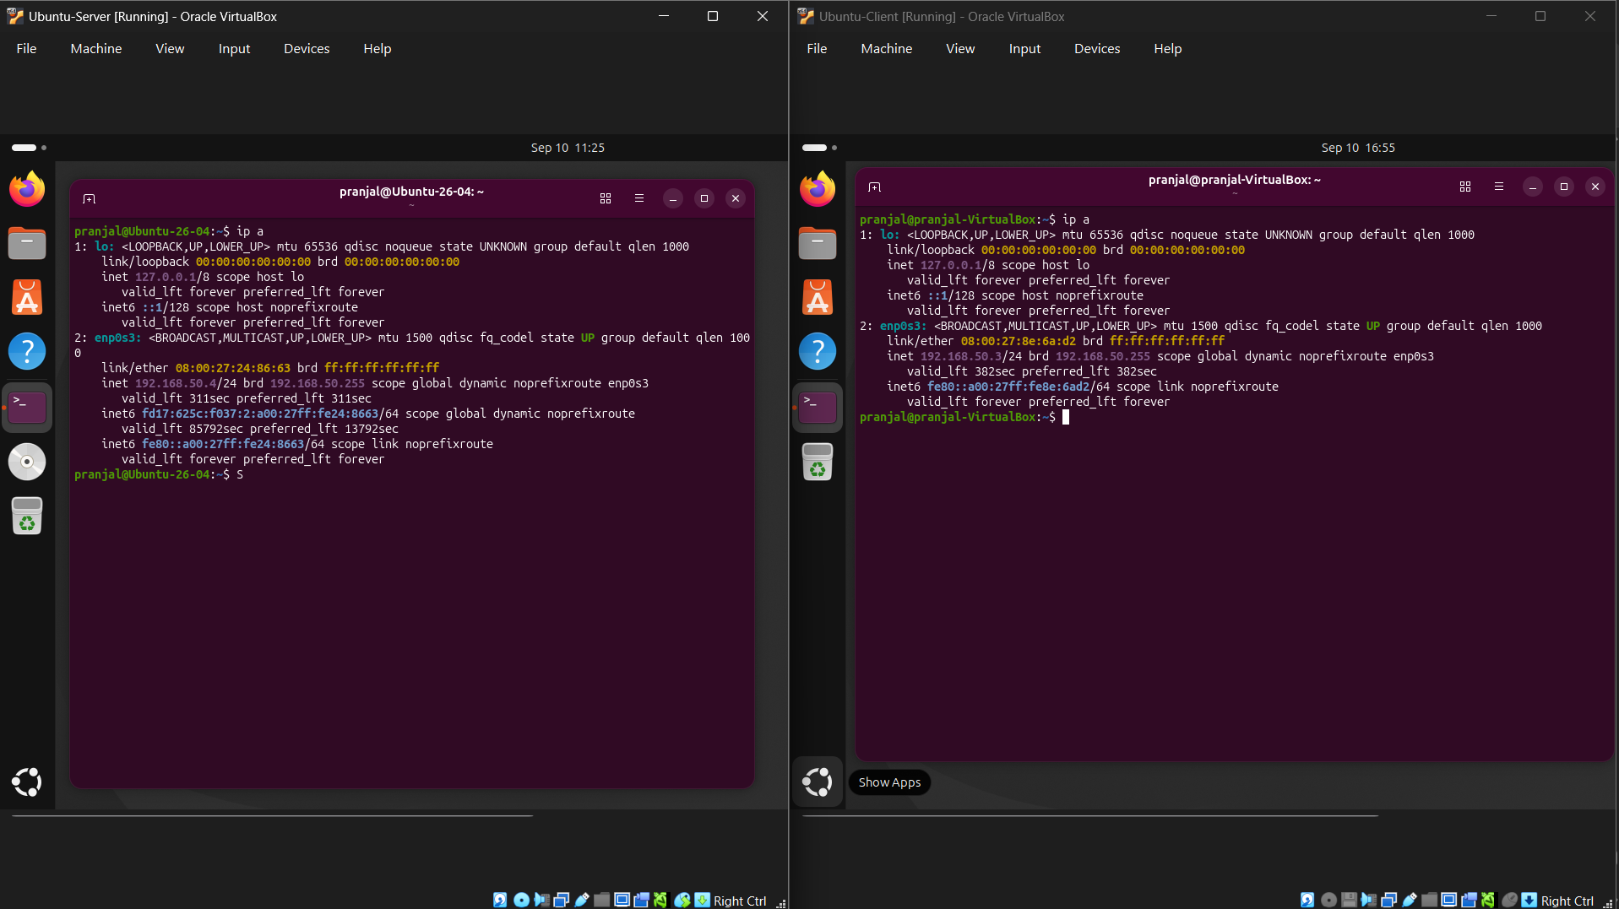

- Establish a connection between the two VMs.
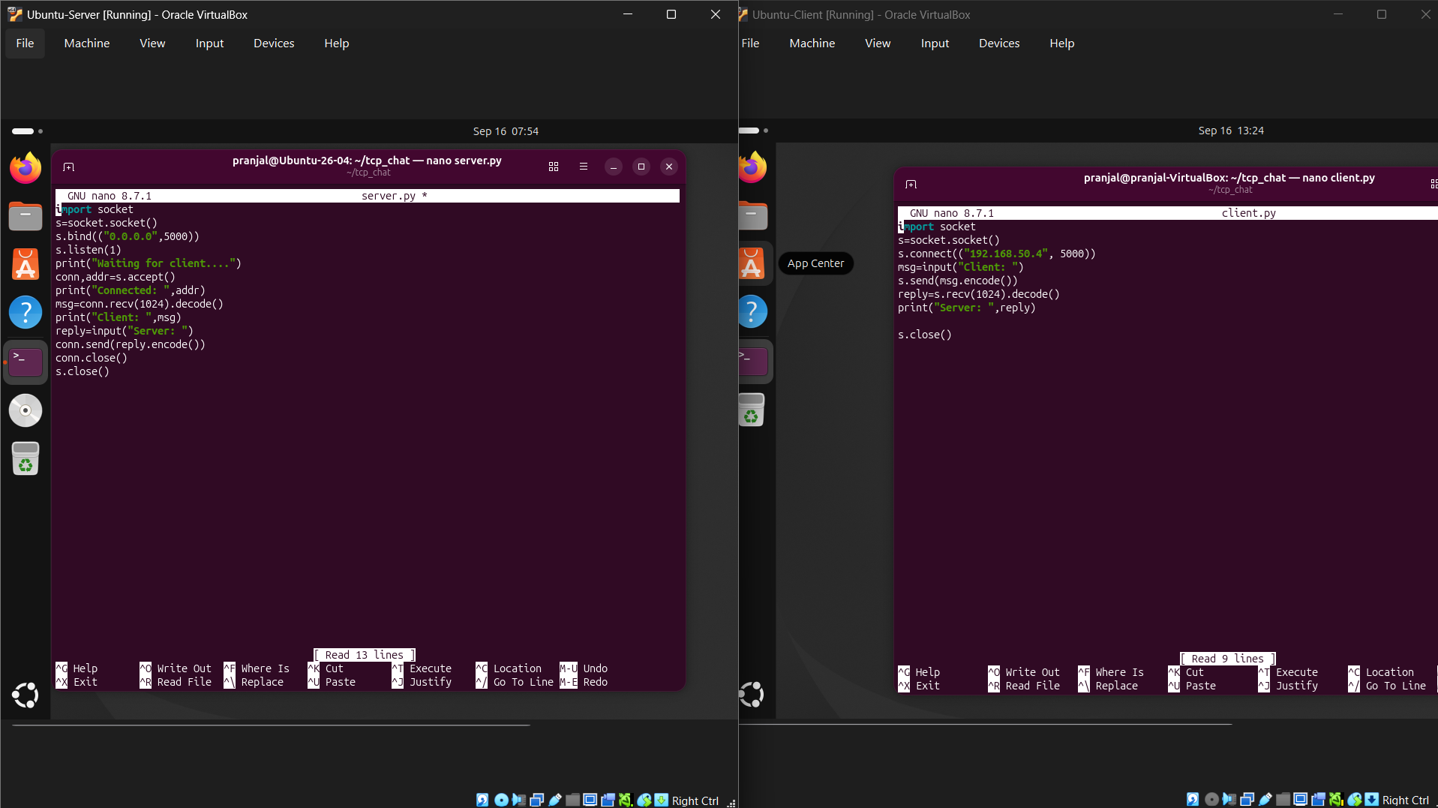

- Testing Connectivity Using Ping


